**CREATE AND CONFIGURE IBM CLOUD SERVICE**

To deploy the IOT platform we need the following constraints to implement the web-Based services to the project

**CREATE IBM WASTON IOT PLATFORM AND DEVICE**

It is the most curcial part of the platform where we deploy a device in IOT WASTON which is a service provider render by IBM cloud and it is more important that we need to take a note on device credential during the creation device in IOT WASTON platform with the help of these credential we can able to connect our services to the desired platform

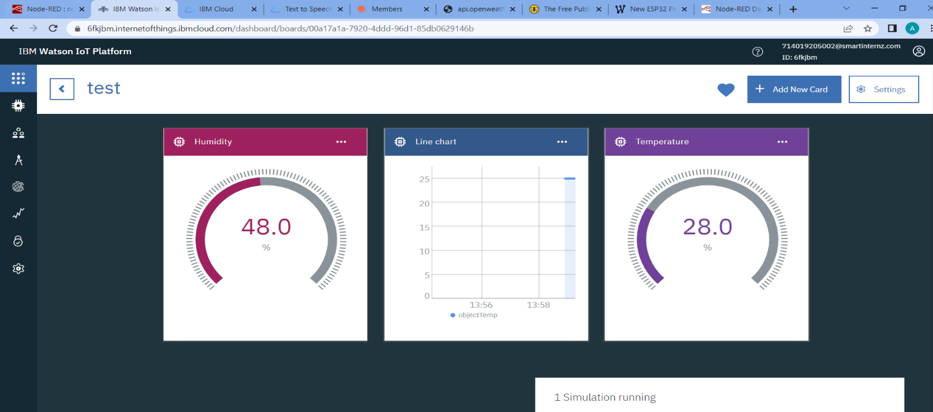

**CARD CREATION**

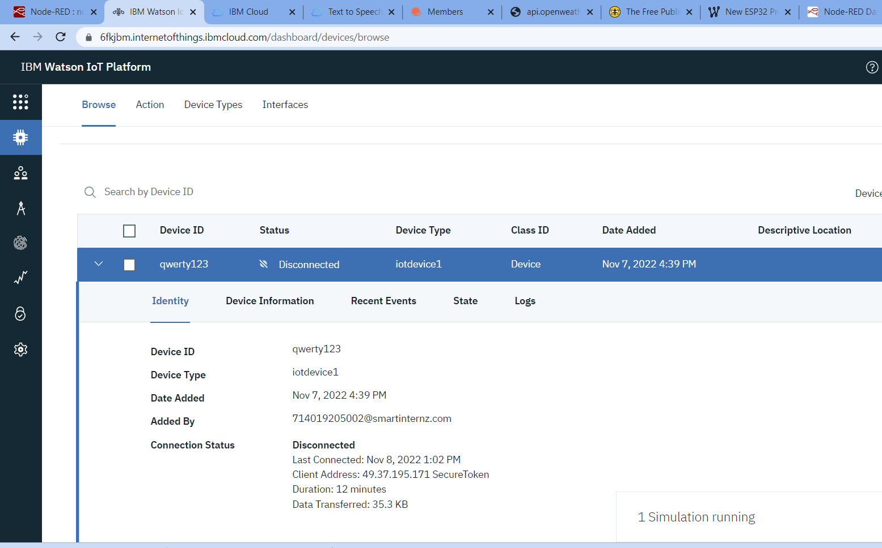

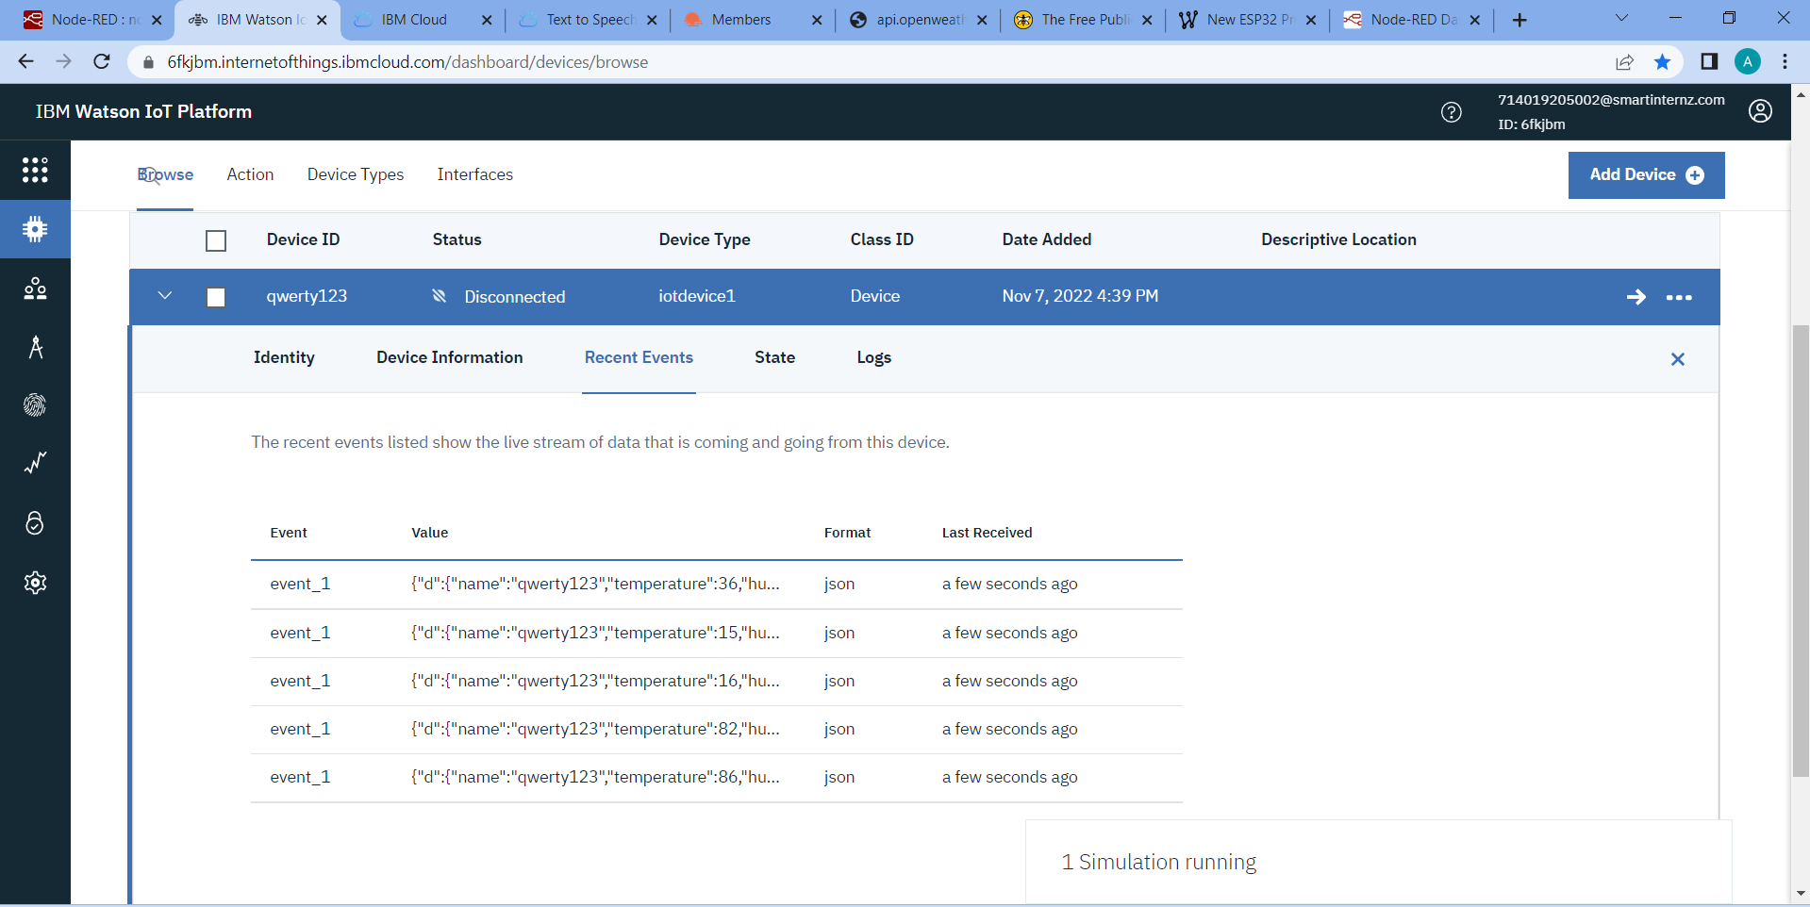

**DEVICE SIMULATION**

**CREATE NOD-RED SERVICES**

To implements the IBM WASTON PLATFORM device values, we need to deploy NOD-RED Services which rendered by IBM Cloud and with the help of it we deploy the IOT as GUI friendly website and as a simulator and it is also connected to python interpreter. And while creating the NOD-RED Services its important to note URL for the NOD-RED flow editor. here we have so many nodes which makes task to be implemented easily

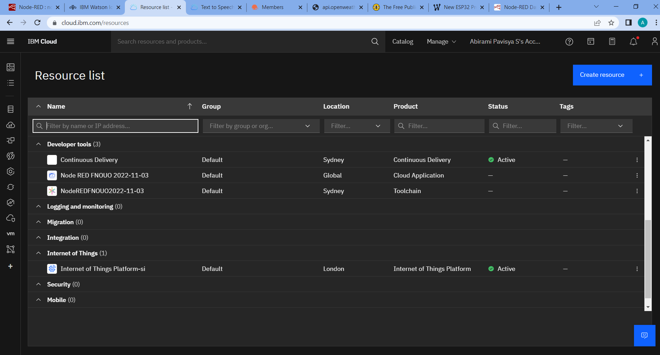

**NODE-RED SERVICE CONNECTION ESTABLISHMENT**

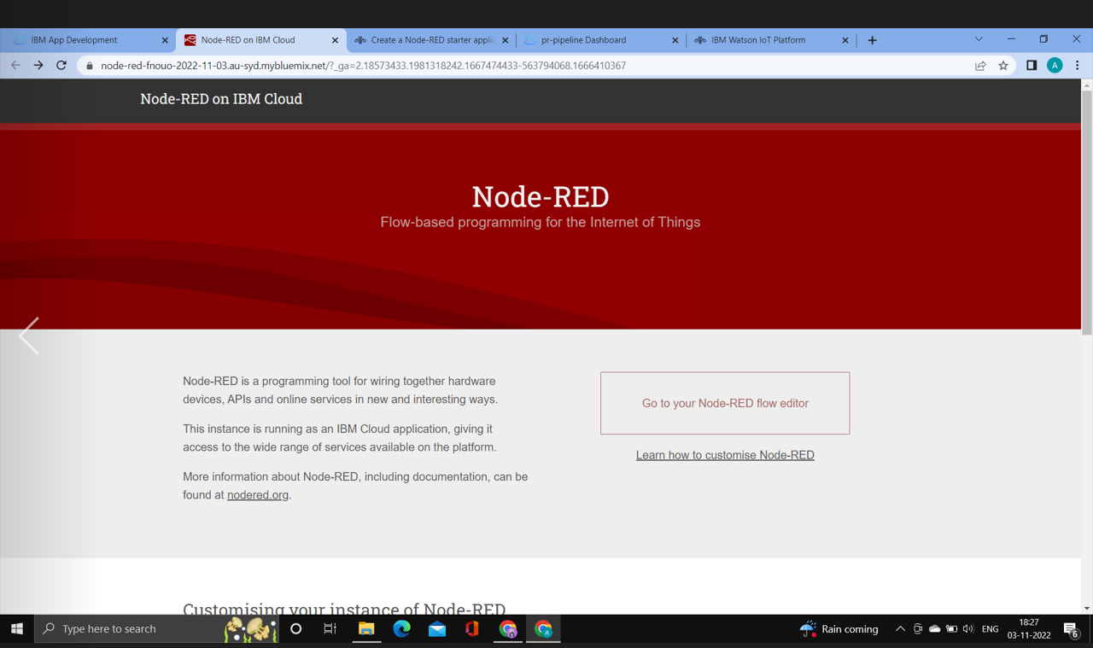

**NODE-RED WEBSITE URL**

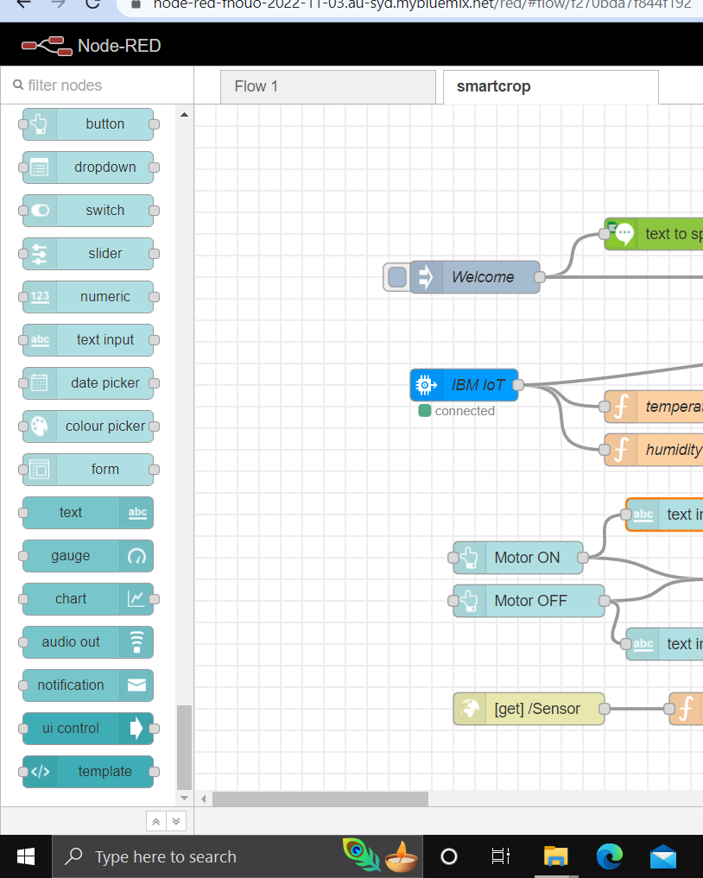 **NODE-RED FLOW EDITOR**

**CREATE A CLOUDANT DATABASE AND CLOUD OBJECT**

In order to store the NOD-RED value or any service provider we need to have a Database here the cloudant database is created inorder to store the values of the sensor reading of the devices

